***Chatsphere***

_______________________________________________________________

Harsh Dua(22IT029) ,Harsh Hadiya (22IT035)

Charotar University Of Science And Technology, Changa

***Abstract*.** DSA Dazzle is an innovative online platform that transforms the study and teaching of Data Structures and Algorithms (DSA). It offers an interactive experience with real-time visualizations, allowing users to observe the dynamic intricacies of algorithms and the structural evolution of data structures. The platform’s intuitive interface enhances learning and comprehension, making it an essential tool for students and educators aiming for a profound grasp of DSA concepts.

***Keywords.*** Data Structures, Visualisation, Animated Algorithms.

___________________________________________________________________________________________

# *1. Introduction*

DSA Dazzle redefines the educational landscape for Data Structures and Algorithms (DSA) with its cutting-edge interactive platform. It invites users to explore the world of algorithms through vivid, real-time visualizations, demystifying their operations and the modifications they induce in data structures. The platform’s user-friendly interface captivates learners, simplifying complex concepts and catalysing the educational process. Algorithm Visualizer stands as a beacon of innovation, reshaping conventional pedagogy and offering a holistic, engaging learning environment for mastering DSA.

***Objective.*** At the heart of our mission is the commitment to enriching comprehension and proficiency in Data Structures and Algorithms (DSA). We achieve this by offering immersive, real-time visualizations and a user-friendly interface, which fundamentally transform conventional educational approaches. By revolutionizing traditional methods, we cultivate a holistic learning environment, empowering individuals to grasp DSA concepts with depth and clarity.

**___________________________________________________________________________________________**

# *2. Literature Review*

## *2.1 Existing Solutions*

## In the landscape of interactive educational platforms, a variety of resources are available to facilitate the comprehension of Data Structures and Algorithms (DSA). Services like Codecademy, LeetCode, and HackerRank present a wealth of learning materials and exercises tailored to DSA. Codecademy offers hands-on coding sessions, inclusive of DSA modules, enabling learners to actively engage with core principles. LeetCode provides an extensive collection of algorithmic challenges, sorted by difficulty, to practice and refine problem-solving abilities. In parallel, HackerRank delivers coding contests and educational content, along with DSA-focused discussions, aiding users in sharpening their programming acumen. These platforms set the standard for DSA Dazzle’s innovation, offering critical perspectives on successful teaching strategies and user engagement features for effective learning.

## *2.2 Goals/Objective*

The primary goals of the DSA Dazzle initiative focus on deepening the grasp and proficiency in Data Structures and Algorithms through engaging and lively educational tools.

## *2.3 Enhanced Understanding*

DSA Dazzle is dedicated to enriching the comprehension of DSA principles by delivering engaging, live visualizations that reveal the mechanics of algorithms and the transformations within data structures. Interactive demonstrations and graphical depictions enable users to investigate DSA topics actively and compellingly, offering profound knowledge of algorithmic functions and data structure modifications during their operation.

## *2.4 Interactive Education*

DSA Dazzle aims to innovate conventional teaching techniques by presenting an interactive educational platform that promotes direct engagement and practical application. Its intuitive interface permits seamless interaction with DSA topics, promoting active participation and discovery. DSA Dazzle provides the means for users to directly manipulate and observe data structures and algorithms, fostering experiential learning and a deeper understanding.

## *2.5 Holistic Learning Environment*

DSA Dazzle is committed to nurturing a complete educational ecosystem, equipped with extensive learning materials and support for all learner levels. It provides structured learning trajectories, instructional content, and exercises that steer users along their DSA educational path. Moreover, DSA Dazzle promotes a collaborative culture and the exchange of knowledge through its community forums, enabling learners to engage with colleagues, seek advice, and benefit from shared experiences. In fostering an inclusive and cooperative educational network, DSA Dazzle endeavours to advance ongoing learning and proficiency in Data Structures and Algorithms.

**____________________________________________________________________________________________**

# *3. Methodology*

## *Data Structures and Algorithms Visualizations*

DSA Dazzle employs interactive visualizations to illustrate the intricacies of data structures and algorithms. Utilizing JavaScript libraries, the platform renders real-time visual representations of algorithms in action and structural changes within data structures. Users can interact with these visualizations to gain a deeper understanding of DSA concepts.

## *User Interface Design*

The user interface of DSA Dazzle is designed to be intuitive and engaging, facilitating seamless navigation and interaction for users. Through thoughtful UI design principles and user feedback, the platform ensures that learners can easily access educational content, visualize algorithms, and engage with interactive exercises.

## *Algorithm Processing Engine*

Behind the scenes, DSA Dazzle employs a powerful algorithm processing engine implemented in JavaScript. This engine analyses user inputs, executes algorithmic operations, and generates real-time visualizations based on algorithmic concepts. Leveraging efficient algorithms and data structures, the processing engine ensures smooth performance and accurate representations of DSA concepts.

## *Learning Pathways and Tutorials*

DSA Dazzle offers curated learning pathways and tutorials to guide users through their DSA learning journey. These pathways are designed to cater to learners of all levels, from beginners to advanced users, and provide a structured approach to mastering DSA concepts. Tutorials supplement the learning experience by offering in-depth explanations, examples, and practice problems.

**______________________________________________________________________________________________________**

# *4. Future Directions*

## *Expansion of Design and Analysis of Algorithms Concepts*

Integrate additional concepts and advanced topics related to the design and analysis of algorithms into the platform. This expansion could include coverage of more complex algorithmic techniques, optimization strategies, and algorithmic paradigms. By providing comprehensive coverage of DSA concepts, DSA Dazzle aims to support learners in developing a deeper understanding and proficiency in algorithmic problem-solving.

## *Implementation of History Tracking*

Introduce a feature to track users' learning history and interactions with the platform. This functionality will allow users to review their progress, revisit previously accessed materials, and track their learning journey over time. Additionally, history tracking can provide valuable insights into user engagement and learning patterns, enabling personalized recommendations and adaptive learning experiences.

## *Integration of Email Response System*

Implement an email response system within DSA Dazzle to facilitate communication and support for users. Users can submit inquiries, feedback, or requests for assistance through the platform, and receive timely responses via email. This feature enhances user engagement and support by providing a direct channel for communication with the platform administrators and educators. Additionally, the email response system can be utilized to deliver personalized updates, announcements, and resources to users, further enhancing the learning experience.

____________________________________________________________________________________________

# *5. Outcomes*

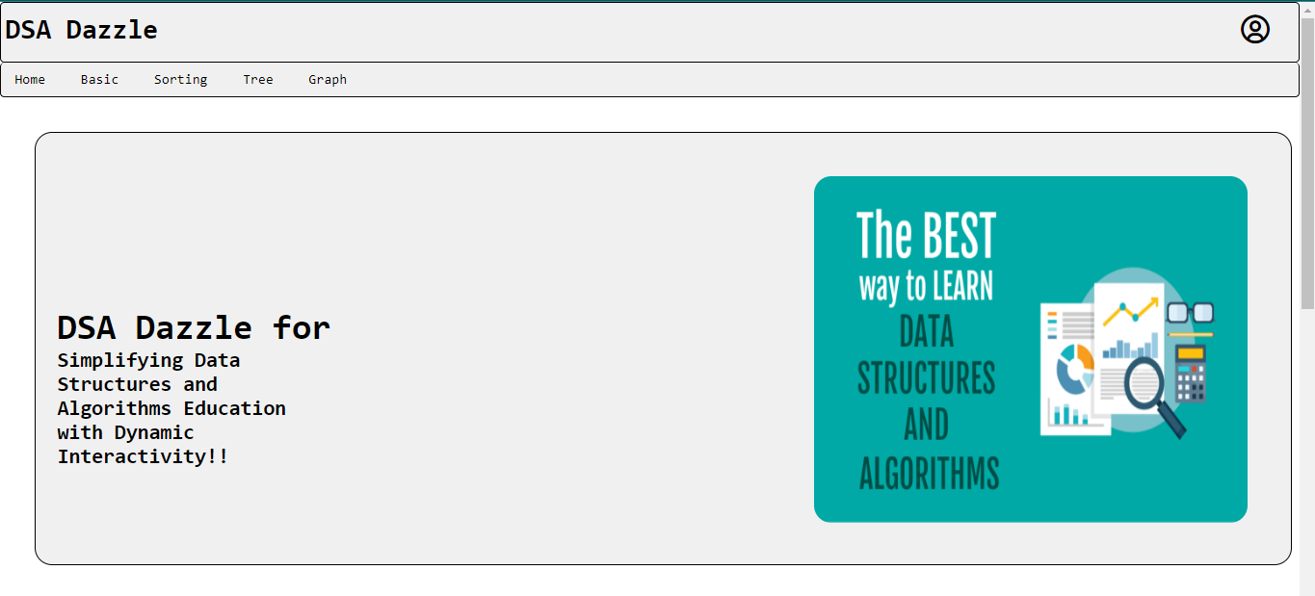

**Fig. 1.** This is the home page of the project

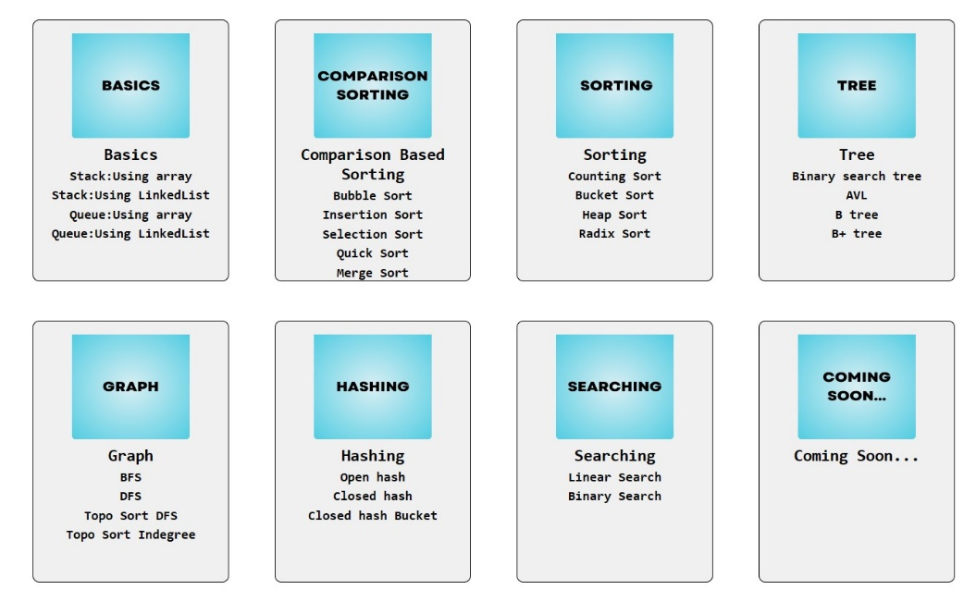

**Fig. 2.** This shows main content of DSA Dazzle

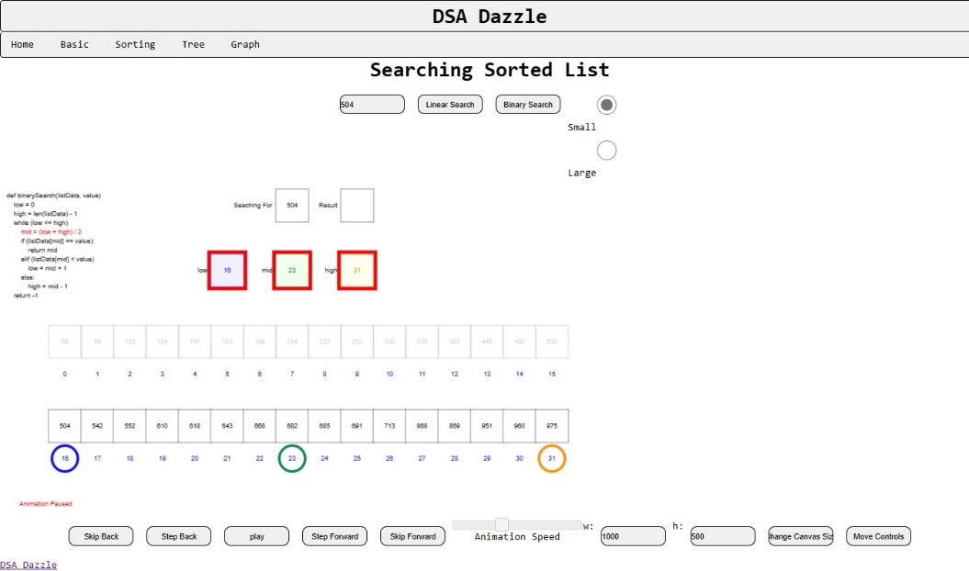

**Fig. 3.** one of the important concept in DSA

Binary Search

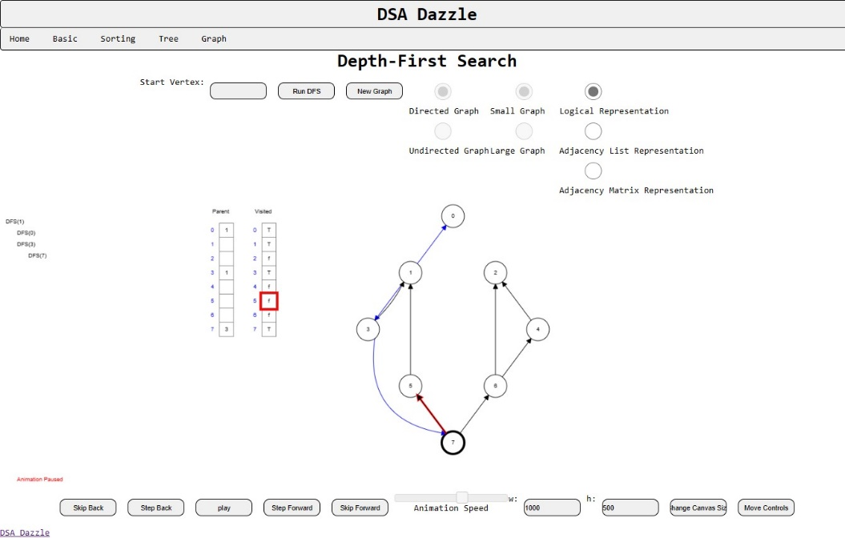

**Fig. 4.** Depth-First Search



**Fig. 5.** For Contact Us

___________________________________________________________________________________________

# *6. Conclusion*

In summary, DSA Dazzle represents a paradigm shift in the landscape of Data Structures and Algorithms (DSA) education. Through its innovative use of immersive visualizations, user-friendly interfaces, and advanced algorithmic processing, DSA Dazzle offers learners an unparalleled platform to delve into and excel in DSA concepts. By providing real-time visualizations, DSA Dazzle grants users unprecedented insights into algorithmic operations and structural transformations within data structures, simplifying complex concepts and fostering effortless interaction. Moreover, with its curated learning pathways, robust algorithm processing engine, and vibrant community engagement, DSA Dazzle not only revolutionizes DSA education but also empowers learners of all levels to explore, comprehend, and master DSA with unprecedented depth and ease. Whether a novice or an expert, DSA Dazzle stands as a beacon of transformative learning, reshaping the educational landscape and empowering learners to embark on an enriching journey of algorithmic discovery.

____________________________________________________________________________________________

# *7. References*